**Erd**

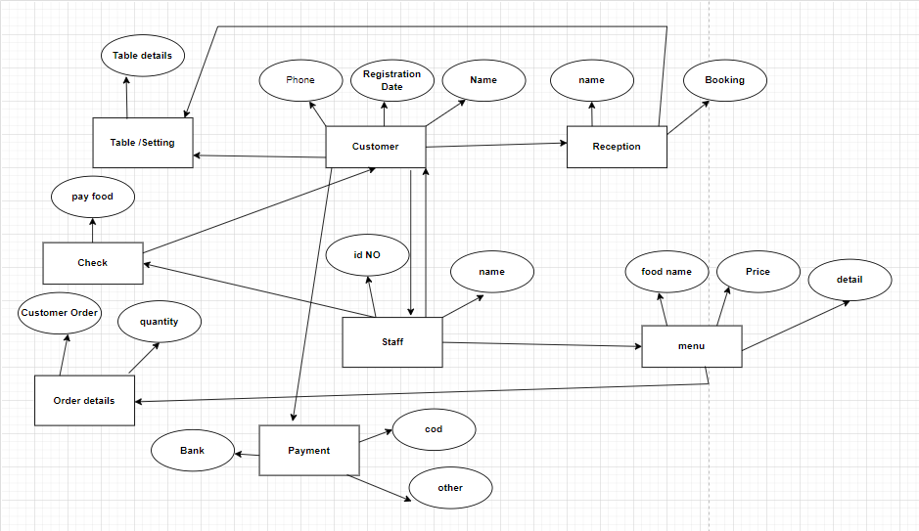

SQL> create user Order_food3

2 system

3

SQL> create user Order_food4

2 identified by Abc;

User created.

SQL> GRANT CREATE SESSION to Order_food4;

Grant succeeded.

SQL> grant create table to Order_food4;

Grant succeeded.

SQL> grant unlimited tablespace to Order_food4;

Grant succeeded.

SQL> Create table Customers

2 (

3 Name varchar(10) Primary key,

4 Phone varchar(15) not Null,

5 Registration varchar(16) Not Null);

Table created.

SQL>

SQL> Create table Staffs(

2 Staff_id number(12),

3 Staff_name varchar2(29),

4 Staff_jobtype varchar2(30));

Table created.

SQL> Create table Orderdetail(

2 ordertype varchar2(9),

3 description varchar2(14),

4 price number(10),

5 type varchar2(10));

Table created.

SQL> create table payments(

2 amount number(10));

Table created.

SQL> Create table receptions (

2 Name varchar(14) Not Null,

3 Booking varchar2(13) Not Null) ;

Table created.

SQL> INSERT INTO Customers (name, Registration, phone)

2 Values('John Doe', 'j34', '123-5');

1 row created.

SQL> INSERT INTO Orderdetail ( ordertype, description, price)

2 VALUES ( 1001, 2, 10.99);

1 row created.

"

SQL> DESCRIBE Staffs;

Name Null? Type

----------------------------------------- -------- ----------------------------

STAFF_ID NUMBER(12)

STAFF_NAME VARCHAR2(29)

STAFF_JOBTYPE VARCHAR2(30)

.

SQL> CREATE TABLE staffsdata (

2 id INT PRIMARY KEY,

3 name VARCHAR(255));

Table created.

SQL> INSERT INTO staffsdata (id,name) VALUES (1,'Osama');

1 row created.

SQL> INSERT INTO staffsdata (id,name) VALUES (2,'WASAM');

1 row created.